**A REPORT**

**ON**

**HANDSMEN THREADS: ELEVATING THE ART OF**

**SOPHISTICATION IN MEN'S FASHION**

**By**

**DHANUSH NERELLA**

**Registration No.**

**AP23110010420**

***Prepared in the partial fulfillment of the***

Summer Internship Course

**AT**

**SALESFORCE SMARTBRIDGE, HYDERABAD**



**SRM UNIVERSITY, AP**

**(July, 2025)**

# Acknowledgements

I would like to express my deepest gratitude to the following individuals and organizations who supported and guided me during the course of my Summer Internship:

* Vice Chancellor and Dean of SRM University, AP
* My Industry Mentor at Salesforce
* My Faculty Mentor for continuous support and guidance

# Abstract

This report documents the Summer Internship project undertaken at Salesforce, titled "HandsMen Threads." The project aimed to improve business efficiency and customer relationship management for a fashion brand by leveraging the Salesforce platform. Initially, the organization faced issues with data fragmentation, delayed inventory updates, and inefficient customer communication. During the internship, a custom Salesforce solution was designed and implemented. This included setting up data models, securing access with roles and profiles, creating user-friendly interfaces, and automating tasks like stock alerts and order confirmations. These enhancements significantly improved data accuracy, reduced manual work, and enhanced customer engagement, positioning HandsMen Threads for smoother operations and future growth.

# Table of Contents Page.no

1. Introduction to the Organization’s Business Sector 4
2. Overview of the Organization 5
3. Plan of Internship Program 6
4. Introduction to the Project 7
5. Main Text 8-9
6. Outcomes 10
7. Appendices 11-12
8. References 13

# Introduction to the Organization’s Business Sector

The Indian fashion and apparel industry is a dynamic and rapidly evolving sector, contributing significantly to the country’s economy. It blends traditional craftsmanship with modern design and caters to a wide range of consumer preferences. With increasing disposable income, fashion consciousness, and exposure to global trends, Indian consumers now demand more personalized and premium fashion experiences.

The digital transformation sweeping across industries has not left fashion untouched. Brands are increasingly leveraging technological tools to streamline their operations, enhance inventory management, offer personalized shopping journeys, and build long-term customer relationships. The use of Customer Relationship Management (CRM) platforms such as Salesforce has become a cornerstone for achieving these goals. CRM enables brands to unify customer data, predict trends using analytics, and deliver tailored experiences across channels — from e-commerce platforms to in-store engagements. In this context, adopting CRM is not just an upgrade but a necessity for fashion businesses to remain competitive and scalable.

# Overview of the Organization

HandsMen Threads is an emerging brand in India’s men’s fashion landscape, known for its dedication to premium tailoring and refined aesthetics. The company prides itself on delivering customized fashion that aligns with contemporary trends while preserving traditional values of craftsmanship. Its product portfolio includes a wide range of tailored suits, casual and formal shirts, ethnic wear for special occasions, and curated accessories to complete the look.

Although the company has maintained a niche and loyal clientele through word-of-mouth and quality-driven operations, its internal processes were largely manual. The absence of centralized systems caused delays in communication between departments, inconsistencies in data management, and missed opportunities for proactive customer service. HandsMen Threads is now at a pivotal growth stage, seeking to expand its digital footprint, enhance operational efficiency, and deliver consistent customer satisfaction across platforms.

The organization’s structure comprises:

* **Sales Team** – responsible for handling both in-store and online sales
* **Design and Tailoring Department** – crafts unique pieces based on customer specifications
* **Customer Support Team** – engages with customers for queries, feedback, and order follow-up
* **Logistics** – ensures timely delivery and inventory tracking

By adopting Salesforce CRM, HandsMen Threads aimed to unify these departments under a single digital ecosystem.

# Plan of Internship Program

**Internship Department:** Salesforce (Smartbridge Internship Program)

**Internship Duration:** 21 May 2025 – 31 July 2025

**Key Activities and Responsibilities:**

* **Salesforce Setup:** Created developer credentials and configured the Salesforce environment to simulate real-world business scenarios.
* **Custom Object Design:** Developed specific objects for entities like ‘Customer’, ‘Order’, and ‘Inventory’. These objects formed the foundation of the CRM architecture.
* **UI Configuration:** Customized page layouts, tabs, and navigation to improve user interaction and minimize confusion for different types of users such as sales executives and warehouse staff.
* **Data Security:** Applied access control mechanisms through profiles, permission sets, and role hierarchies. Sensitive business data was safeguarded by restricting access based on job function.
* **Automation Implementation:** Designed and executed record-triggered flows for key business events. For example, sending an email confirmation when an order is placed or issuing a stock alert when inventory falls below a threshold.
* **Reporting and Analytics:** Developed dashboards that showed real-time customer metrics and inventory insights. Created custom reports to help managers analyze order trends and customer behavior.

# Introduction to the Project

The project "HandsMen Threads" was initiated to resolve critical challenges related to fragmented data storage, communication inefficiencies, and delayed decision-making processes. The lack of a centralized CRM led to problems such as lost customer information, order tracking issues, and a general disconnect between departments.

The main objective was to leverage Salesforce’s ecosystem to centralize and automate business processes. This involved:

* Designing **custom data models** tailored to the company’s fashion-oriented needs.
* Creating user interfaces that reflected the practical workflows of the business.
* Implementing **automation mechanisms** to reduce repetitive manual tasks.
* Ensuring **data protection** by structuring the right access hierarchy.
* Building **real-time dashboards** to provide management with instant insights into operational metrics

.

# Main Text

1. **Environment Setup:**
   * Established development and testing environments within Salesforce.
   * Ensured secure login protocols with two-factor authentication and session timeouts.
2. **Data Model Configuration:**
   * Defined custom objects such as Customer__c, Order__c, and Inventory__c to align with HandsMen Threads’ business needs.
   * Created master-detail and lookup relationships to represent real-world dependencies (e.g., each order is linked to a customer and inventory item).
   * Tabs and apps were designed for easy navigation and logical grouping of functionalities.
3. **User Access and Security:**
   * Developed custom profiles for roles such as Sales Agent, Inventory Manager, and Admin.
   * Configured sharing settings to allow record-level security using role hierarchies.
   * Applied field-level security to prevent unauthorized access to confidential fields such as pricing margins.
4. **UI Design:**
   * Used Lightning App Builder to enhance user experience with drag-and-drop components.
   * Customized record pages with key information highlighted using Dynamic Forms.
   * Included quick action buttons for frequently used functions like "Send Invoice" or "Mark as Delivered".
5. **Process Automation:**
   * Implemented flows triggered by record creation or status change. For instance, when inventory goes below a threshold, an alert is sent to the Inventory Manager.
   * Configured automated email templates to keep customers updated about their order status.
   * Setup loyalty point update logic based on total purchase amount, encouraging repeat business.
6. **Dashboards and Reporting:**
   * Developed dashboards to track sales conversion, customer acquisition, inventory movement, and top-selling products.
   * Customized filters allowed management to view reports for specific dates, regions, or product lines.
   * Reports were scheduled to be automatically emailed to department heads at the beginning of each week.

# Outcomes

* Successfully implemented a customized Salesforce-based CRM system, fully aligned with the business model of HandsMen Threads.
* Customer information and order details are now centralized, enabling quicker access and service delivery.
* Automation significantly reduced manual follow-ups and repetitive data entry.
* Sales and support teams now work with real-time data, enabling faster decision-making.
* Inventory managers receive automated stock alerts, reducing the chance of stockouts or over-ordering.
* Business leaders use interactive dashboards to track KPIs and make data-driven decisions.
* Overall, the project increased operational efficiency, customer satisfaction, and team productivity.

.

# Appendices Handsmen customer

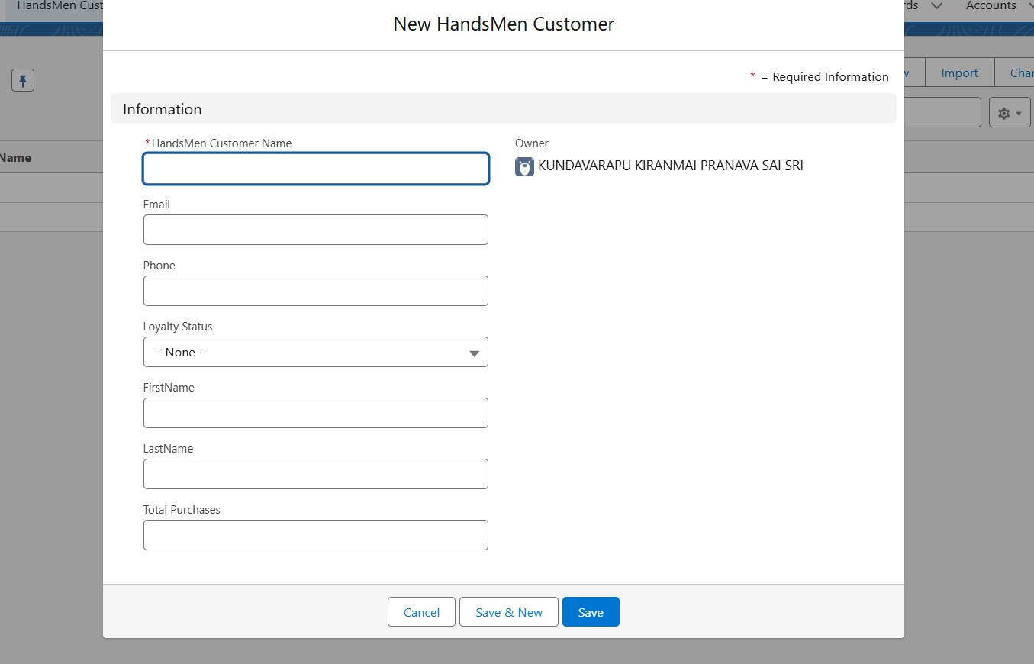

# Handsmen order

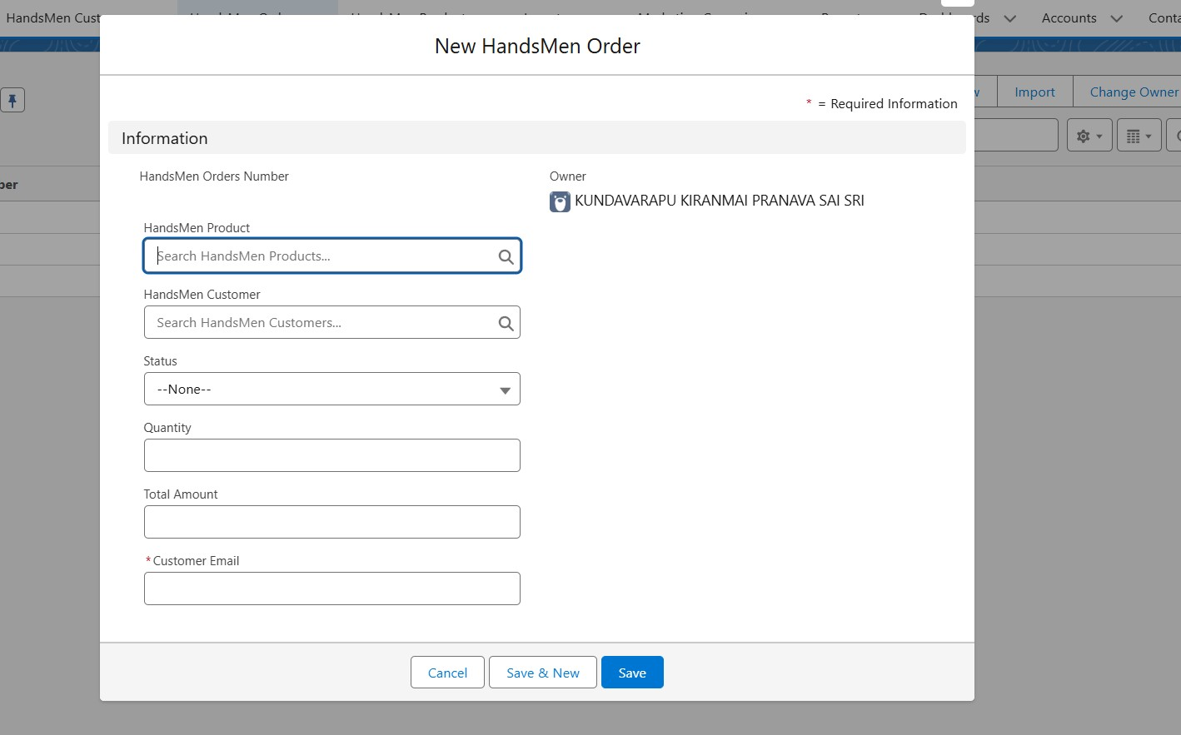

# Handsmen Product

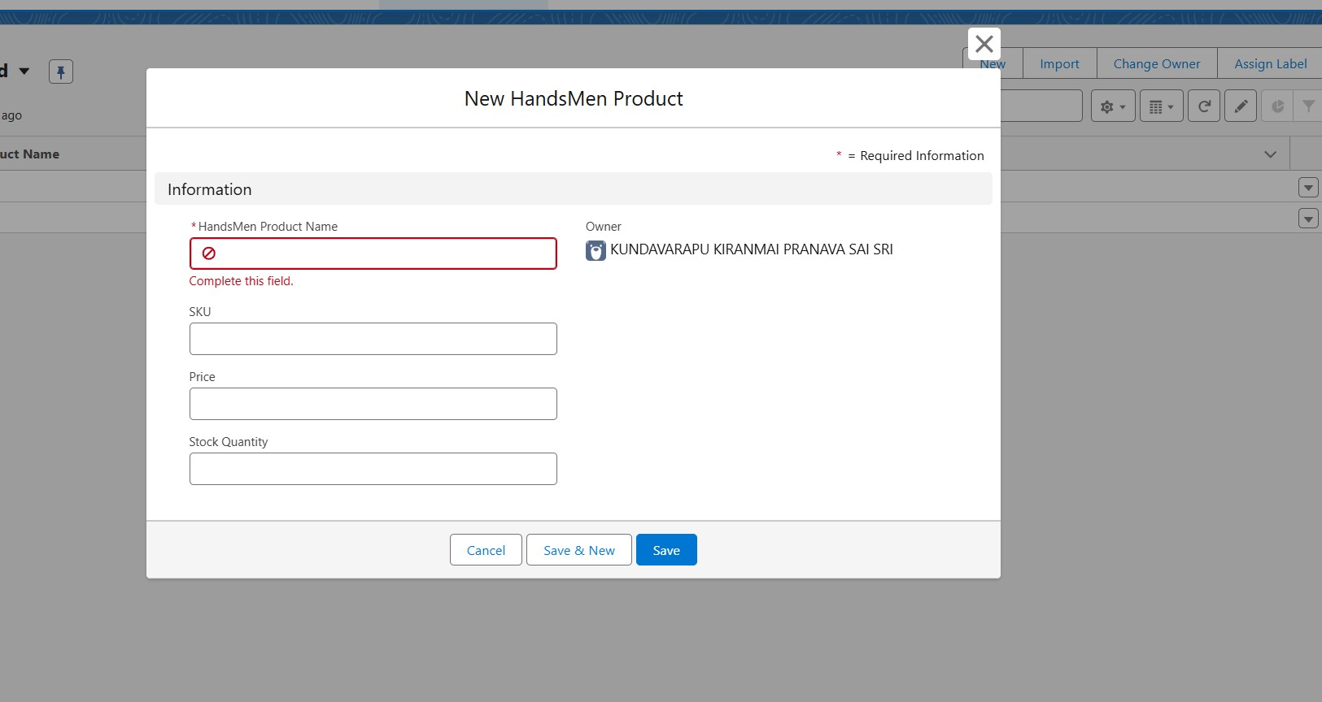

# Inventory

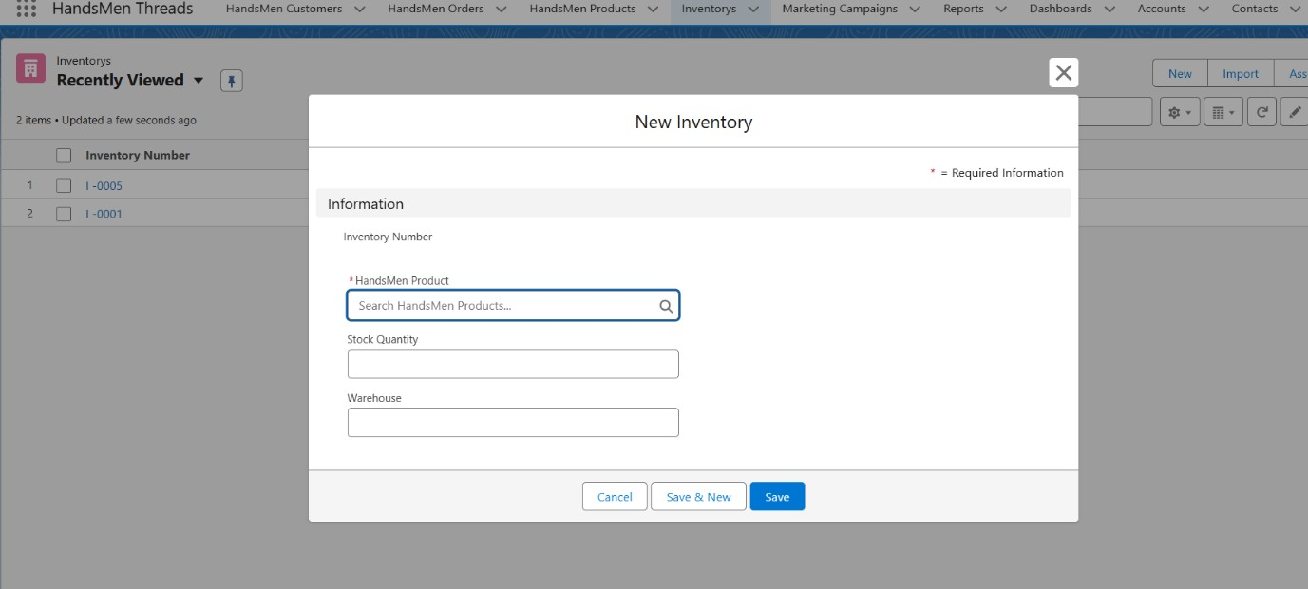

# References

* Salesforce Trailhead Modules – [https://trailhead.salesforce.com](https://trailhead.salesforce.com/)
* Skill Wallet – <https://myskillwallet.ai/login>
* SmartBridge Internship Program Resources